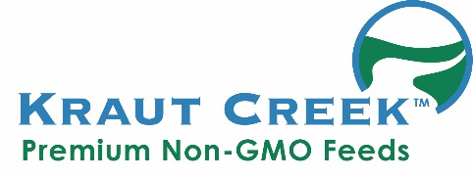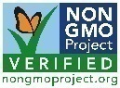

Soy Free/Non-GMO
Chicken Grower 18%

A Complete Feed For Chickens From

4 Weeks of Age

GUARANTEED ANALYSIS
Crude Protein (minimum) .............................. 18.0 %
Lysine (minimum) .......................................... 0.40 %
Methionine (minimum) .................................... 0.60%
Crude Fat (minimum) .................................... 5.50 %
Crude Fiber (maximum) ................................. 4.00 %
Calcium (minimum) ....................................... 0.50 %
Calcium (maximum) ...................................... 1.50 %
Phosphorus (minimum) ................................. 0.80 %
Salt (minimum) ............................................... 0.30 %
Salt (maximum) ............................................. 0.80 %
INGREDIENT STATEMENT
Corn, Peas, Sesame Meal, Wheat, Barley, Fish Meal, Sunflower Oil, Crab Meal, *Sodium Bentonite(clay), Diatomaceous Earth, **(Monocalcium Phosphate, Organic Dehydrated Kelp Meal, Salt, DL Methionine, Calcium Carbonate, Vitamin A Supplement, Vitamin D3 Supplement, Vitamin E Supplement, Menadione Dimethylpyrimidinol Bisulfite, Riboflavin Supplement, D-Calcium Pantothenic Acid, Niacin Supplement, Choline Chloride, Vitamin B12 Supplement, Folic Acid, Thiamine Mononitrate, Pyridoxine Hydrochloride, Biotin, Manganese Sulfate, Ferrous Sulfate, Zinc Sulfate, Copper Sulfate, Sodium Selenite, Organic Sunflower Oil, Dried Aspergillus oryzae Fermentation Extract, Active Dry Yeast, Dried Lactobacillus acidophilus Fermentation product, Dried Lactobacillus casei Fermentation product,Dried Lactobacillus plantarum Fermentation product, Dried Enterococcus faecium Fermentation product, Dried Bacillus licheniformis Fermentation product, Dried Bacillus subtilis Fermentation Product).
*
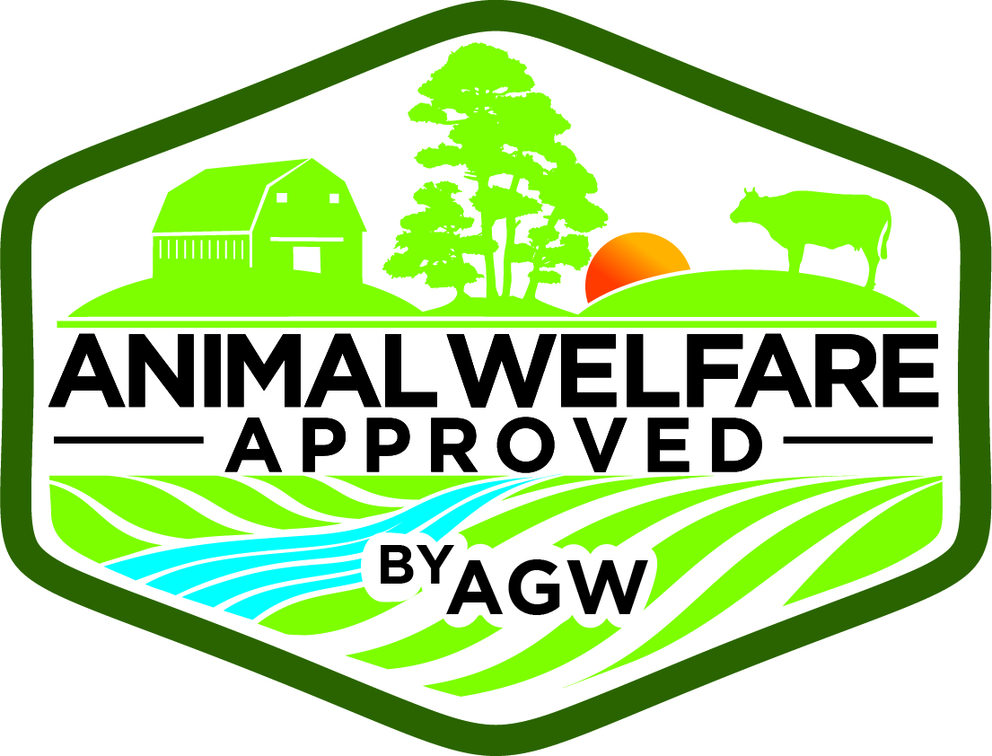***
** 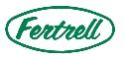
FEEDING DIRECTIONS
Feed as the sole ration to broilers/pullets from 4 weeks of age. Always provide plenty of fresh water.

Manufactured For
Kraut Creek Natural Feed Co.
Greenville, OH 45331
www.krautcreek.com
(833)4NONGMO(466-6466)

Net Weight 50 lb (22.67 kg) or Bulk

***Use of this product is compliant with the AWA program when used in accordance with the AWA standards.

Vulcan green
Soy Free/Non-GMO
Chicken Grower 18%
A Complete Feed For Chickens From
4 Weeks of Age

GUARANTEED ANALYSIS
Crude Protein (minimum) .............................. 18.0 %
Lysine (minimum) .......................................... 0.40 %
Methionine (minimum) .................................... 0.60%
Crude Fat (minimum) .................................... 5.50 %
Crude Fiber (maximum) ................................. 4.00 %
Calcium (minimum) ....................................... 0.50 %
Calcium (maximum) ...................................... 1.50 %
Phosphorus (minimum) ................................. 0.80 %
Salt (minimum) ............................................... 0.30 %
Salt (maximum) ............................................. 0.80 %
INGREDIENT STATEMENT
Corn, Peas, Sesame Meal, Wheat, Barley, Fish Meal, Sunflower Oil, Crab Meal, *Sodium Bentonite(clay), Diatomaceous Earth, **(Monocalcium Phosphate, Organic Dehydrated Kelp Meal, Salt, DL Methionine, Calcium Carbonate, Vitamin A Supplement, Vitamin D3 Supplement, Vitamin E Supplement, Menadione Dimethylpyrimidinol Bisulfite, Riboflavin Supplement, D-Calcium Pantothenic Acid, Niacin Supplement, Choline Chloride, Vitamin B12 Supplement, Folic Acid, Thiamine Mononitrate, Pyridoxine Hydrochloride, Biotin, Manganese Sulfate, Ferrous Sulfate, Zinc Sulfate, Copper Sulfate, Sodium Selenite, Organic Sunflower Oil, Dried Aspergillus oryzae Fermentation Extract, Active Dry Yeast, Dried Lactobacillus acidophilus Fermentation product, Dried Lactobacillus casei Fermentation product,Dried Lactobacillus plantarum Fermentation product, Dried Enterococcus faecium Fermentation product, Dried Bacillus licheniformis Fermentation product, Dried Bacillus subtilis Fermentation Product).
*
***
**
FEEDING DIRECTIONS
Feed as the sole ration to broilers/pullets from 4 weeks of age. Always provide plenty of fresh water.

Manufactured For
Kraut Creek Natural Feed Co.
Greenville, OH 45331
www.krautcreek.com
(833)4NONGMO(466-6466)

Net Weight 50 lb (22.67 kg) or Bulk

***Use of this product is compliant with the AWA program when used in accordance with the AWA standards.

Soy Free/Non-GMO
Chicken Grower 18%
A Complete Feed For Chickens From

4 Weeks of Age

GUARANTEED ANALYSIS
Crude Protein (minimum) .............................. 18.0 %
Lysine (minimum) .......................................... 0.40 %
Methionine (minimum) .................................... 0.60%
Crude Fat (minimum) .................................... 5.50 %
Crude Fiber (maximum) ................................. 4.00 %
Calcium (minimum) ....................................... 0.50 %
Calcium (maximum) ...................................... 1.50 %
Phosphorus (minimum) ................................. 0.80 %
Salt (minimum) ............................................... 0.30 %
Salt (maximum) ............................................. 0.80 %
INGREDIENT STATEMENT
Corn, Peas, Sesame Meal, Wheat, Barley, Fish Meal, Sunflower Oil, Crab Meal, *Sodium Bentonite(clay), Diatomaceous Earth, **(Monocalcium Phosphate, Organic Dehydrated Kelp Meal, Salt, DL Methionine, Calcium Carbonate, Vitamin A Supplement, Vitamin D3 Supplement, Vitamin E Supplement, Menadione Dimethylpyrimidinol Bisulfite, Riboflavin Supplement, D-Calcium Pantothenic Acid, Niacin Supplement, Choline Chloride, Vitamin B12 Supplement, Folic Acid, Thiamine Mononitrate, Pyridoxine Hydrochloride, Biotin, Manganese Sulfate, Ferrous Sulfate, Zinc Sulfate, Copper Sulfate, Sodium Selenite, Organic Sunflower Oil, Dried Aspergillus oryzae Fermentation Extract, Active Dry Yeast, Dried Lactobacillus acidophilus Fermentation product, Dried Lactobacillus casei Fermentation product,Dried Lactobacillus plantarum Fermentation product, Dried Enterococcus faecium Fermentation product, Dried Bacillus licheniformis Fermentation product, Dried Bacillus subtilis Fermentation Product).
*
***
**
FEEDING DIRECTIONS
Feed as the sole ration to broilers/pullets from 4 weeks of age. Always provide plenty of fresh water.

Manufactured For
Kraut Creek Natural Feed Co.
Greenville, OH 45331
www.krautcreek.com
(833)4NONGMO(466-6466)

Net Weight 50 lb (22.67 kg) or Bulk

***Use of this product is compliant with the AWA program when used in accordance with the AWA standards.

